To run in Ubuntu

Download e(fx)clipse
http://www.eclipse.org/efxclipse/install.html
(or use the copy in google drive)
https://drive.google.com/file/d/0B2Nnws8J_7IOUkc5NXV3WHFYeHc/edit?usp=sharing

download JDK jdk1.7.0_21
(or use the copy in google drive jdk-7u21-linux-i586.tar.gz)
https://drive.google.com/file/d/0B2Nnws8J_7IOT0tyaXVzUktkX0k/edit?usp=sharing

change the vm used by eclipse
(you may skip this step if the jdk is installed on your system and you are able to run eclipse after unzipping)

open eclipse/eclipse.ini

add this line:

-vm (add the line below after this argument)
[path to where you unzipped the jdk]/jdk1.7.0_21/bin

eg.
-vm
/home/user/Desktop/FYP/jdk-jre/jdk1.7.0_21/bin

REMEMBER TO INSTALL AJDT plugin
http://download.eclipse.org/tools/ajdt/42/dev/update

follow setup instructions

--------------------------------------------------------------------------------------------------------------------
Tested on Eclipse 4.2.1 with Lubuntu.

Create a the directory structure & clone repositories
mkdir tod
cd tod/
mkdir ws-tod-0.9
mkdir git
cd git/

Use the new version below (with native agent for linux already in agent folder)
git clone https://github.com/kairen88/tod.git;
git clone https://github.com/kairen88/zz.eclipse.utils.git;
git clone https://github.com/kairen88/zz.jinterp.git;
git clone https://github.com/kairen88/zz.utils.git;

or use the original version below:
git clone -b 0.9 https://github.com/gpothier/stiq.git tod;
git clone https://github.com/gpothier/zz.eclipse.utils.git;
git clone https://github.com/gpothier/zz.jinterp.git;
git clone https://github.com/gpothier/zz.utils.git;

Ensure everything is checked out ok, you should have these 4 directories in the git subfolder:
tod
zz.eclipse.utils
zz.jinterp
zz.utils

Import projects
Launch Eclipse using the recently created ws-tod-0.9 as your workspace. Ensure you have both a jdk 6 and a jdk 7 defined, and the AJDT plugin installed (a git plugin would also be helpful).
Import the projects into the workspace, starting with the zz.utils ones.

Choose File > Import, then Projects from Git: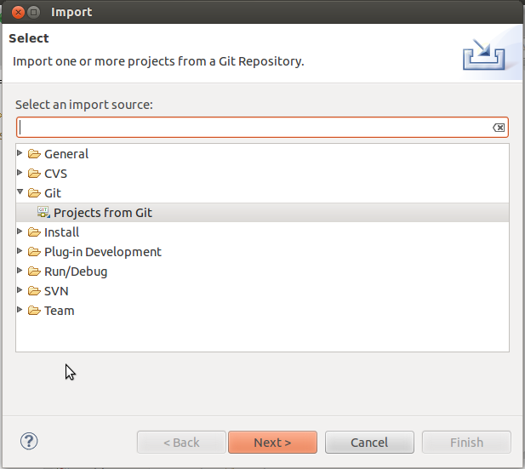

The first time you have to add the 4 local repositories from the directories created in the first step: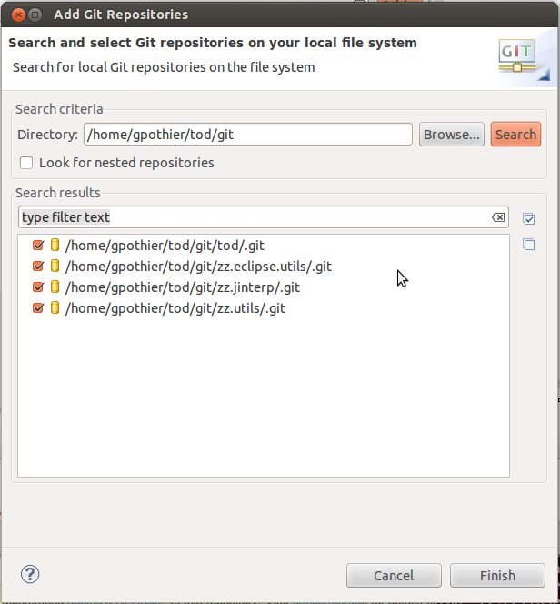

Then choose the zz.* ones for importing (as there is one project per repository, you must run the import command for each one). 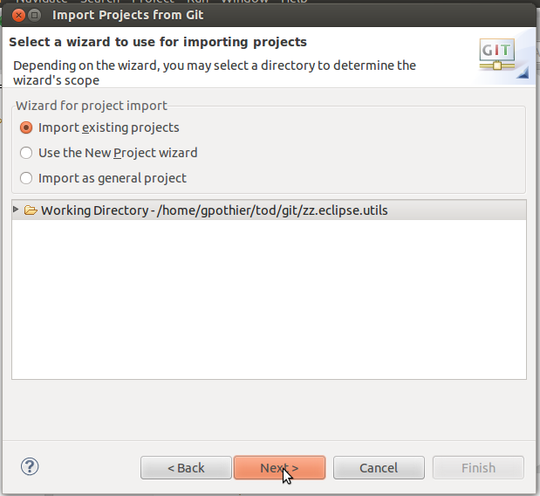
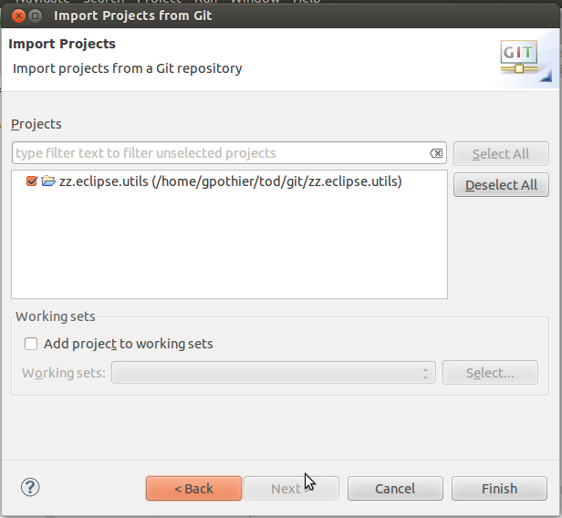
Once you have the zz.* projects, import these tod projects from the tod repository:
TOD-agent
TOD-core
TOD-dbgrid
TOD-evdb1
TOD-evdbng
tod.plugin.v2
tod.plugin.ajdt

Ready
Your Eclipse workspace should now look like this: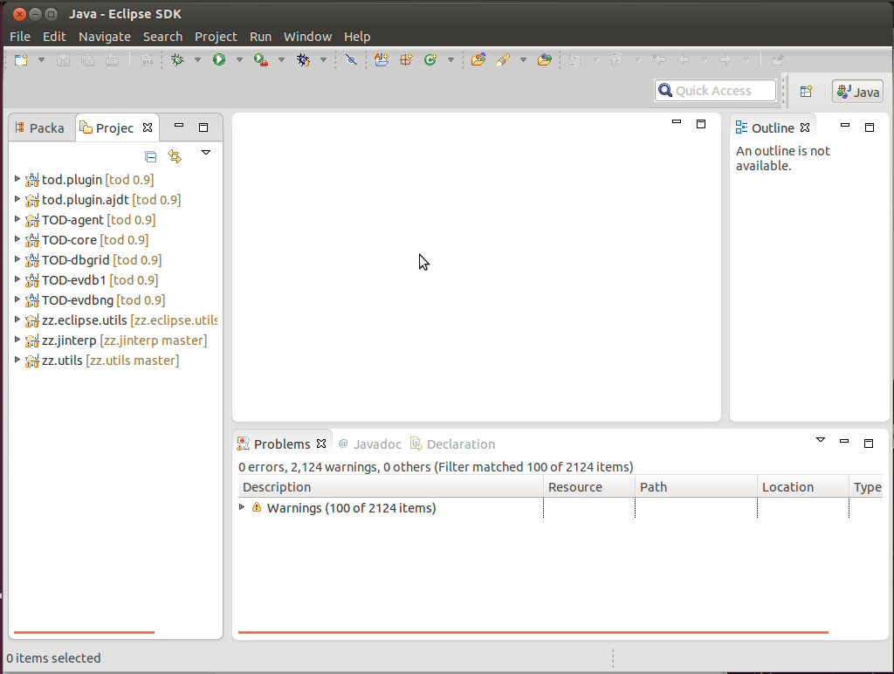

All the projects are loaded, there are no compilation errors.

if you get a compilation error: TOD-Core has missing files
check the build path, if required remove:

.../jfxrt.jar

After adding new proj (LDB) project has lots of errors (does not recog ILogBrowser etc.)

Check Build Path setup - need to include projects eg. TOD-core in build path -> Projects:

TOD-core:

TOD-agent
zz.jinterp
zz.utils

zz.jinterp:

zz.utils

tod.plugin.adjt:

TOD-core

TOD-evdbng:

TOD-agent
TOD-core
TOD-dbgrid
zz.utils

TOD-evdb1:

TOD-core
zz.utils

TOD-dbgrid:

TOD-agent
TOD-core
zz.utils

Run Eclipse with the plugin
Right click the tod.plugin project, select Run As... Eclipse Application. A new Eclipse instance should show up. Close it, then open the Run config for the newly created launch, and ensure that your Eclipse app runs with Java 7 (in the Java Runtime Environment group):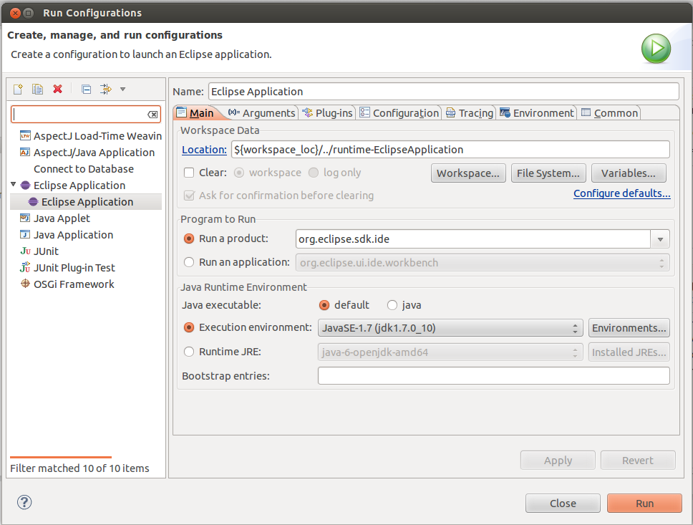

Then add this parameter to the VM: -Ddev.path=${workspace_loc}

Now you should be able to run Eclipse with the TOD plugin without problems.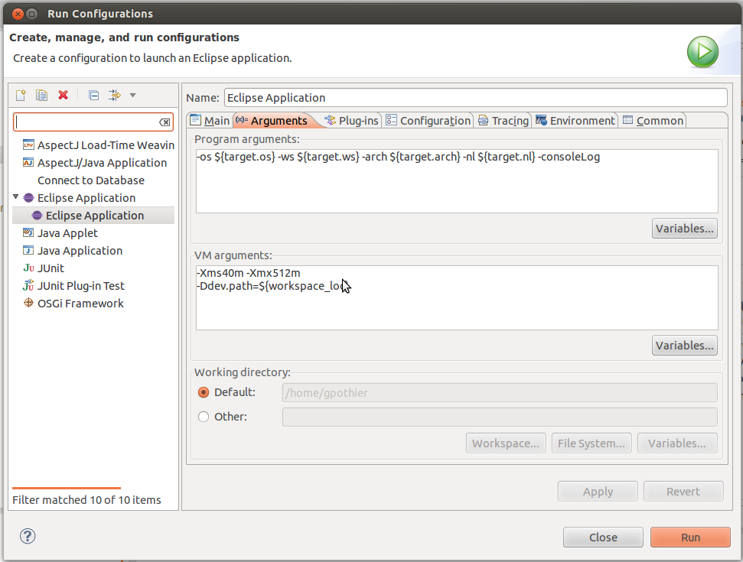

--------------------------------------------------------------------------------------------------------------------

copy libtod-agent15.so into git/tod/agent/

from plugin download tod.plugin_0.9.7.4/plugins/tod.plugin_0.9.7.4/lib
(or copy from git repo)

To run standalone gui

TOD-core/src/debugger/tod.gui

run as > application

then setup configuration as stated in site, use evdbng

*if TOD is now working create a new folder LDB and pull LDB:
git clone https://github.com/kairen88/LDB.git

Import this project into the same workspace as the working TOD

ERRORS: ----------------------------------------------------------------------
if you get errors about missing a project 'Test' or library jfxrt.jar, just got to build path and remove them

create a new java project NumRec (this is the sample code LDB is currently using)
The sample code can be copied from the file NumRecSampleCode.txt in the LDB project

if you get an error 'unable to find Program2.txt' just create a file named Program2.txt in resources under LDB project and paste the code from NumRec there
-------------------------------------------------------------------------------------------------------------------

use the tod plugin already installed in e(fx)clipse to run the NumRec sample code first to populate the database

then run LDB as application

Compiling native agent for the platform

install ANT

compile the agent.dll using the build.xml

locate the build.xml dir in command line

eg. ant clean

Links:

http://wiki.apache.org/ant/AntOnWindows

http://code.google.com/p/winant/

http://wiki.eclipse.org/FAQ_What_is_the_use_of_the_build.xml_file%3F

http://www.coderanch.com/t/107220/tools/Run-build-xml

http://www-stat.stanford.edu/~naras/java/course/lec5/lec5.html

